Guidance for emergency management planning for schools hosting international students
This guidance is designed to assist you incorporating your responsibilities as a host of international students when developing your Emergency Management Plan (EMP).
Remember to ensure that any details about student demographics, including international students, remain deidentified.

Facility Profile
It is useful to indicate in your EMP that your schools hosts international students, and there are a number of ways to do this.

Additional Profile Information
We recommend that you mention this in the free text section called Additional Profile Information in the Facility Profile tab.
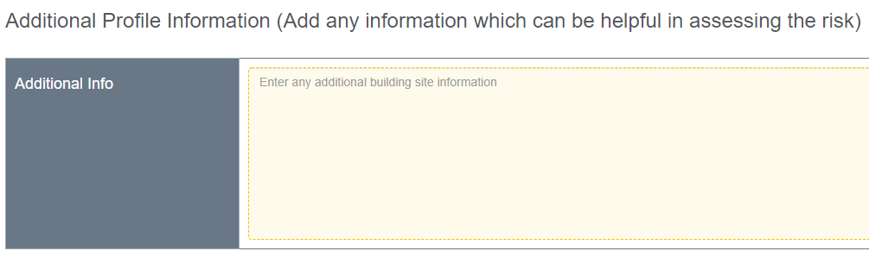
Example:

Additional Needs Profile
List the number of international students attending your school in the table provided. You can do this by creating a new row by selecting Add additional needs category in the bottom right of the table and selecting Other before writing ‘International students’ in the Category text box and by entering the total number of current international students in the right column titled Number of students.
This helps to keep your international students in the front of mind when updating your EMP.

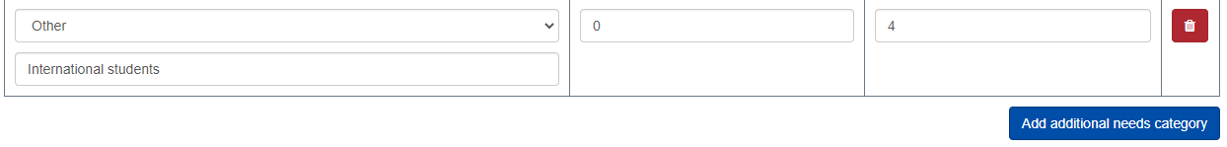
Contacts

Additional Profile Information
Emergency Contacts
Be sure to include the details of your International Student Coordinator in the list of Internal Key Contacts per the example below.
This will ensure anyone using your school EMP can contact them easily should an incident impact one or more international students.

Risk Assessment
In most instances, international students will be covered by your assessment of the risks posed to your whole school cohort.
The one specific hazard that may impact international students and not the rest of your school population is the disruption to their homestay arrangements, which is linked to legal obligations, as well as the safety and wellbeing of individual international students.
You can select the Disruption to international student homestay arrangements option from the drop-down menu in the Risk Assessment section of your EMP, which will include some details for you to review and contextualise based on your school’s specific situation.
You can add, remove and change the controls as appropriate for your school setting, and you will need to review and rate the risk according to the department’s risk assessment policy and guidance.

Emergency and Critical Incident Response Procedures

Core Response Procedures
Review each of your response procedures listed under the Core Response Procedures (onsite evacuation, offsite evacuation, lockdown, lock out and shelter in place) and insert a step that reminds your school to ensure appropriate steps are taken should international students be impacted by each of these situations.
The following step can be inserted in any of your Core or Specific Emergent Response Procedures and adapted as required:
“If the incident involves or impacts international students, ensure International Student Coordinator is alerted, as well as the International Education Division if required. Ensure host parents and parents are contacted as required.”
This can be demonstrated in the example response procedure for an on-site evacuation below (inserted step in blue):
Onsite evacuation
When it is unsafe for students, staff and visitors to remain inside the school building the Chief Warden on-site will take charge and activate the Incident Management Team if necessary.
- Call 000 for emergency services and seek and follow advice.
- Evacuate students, staff and visitors to your INSERT LOCATION HERE
  - Report emergency via eduSafe Plus or to the Incident Support and Operations Centre on 1800 126 126.
- Take your emergency kit/first aid kit (including your student and staff attendance lists and a copy of this EMP).
- Once at your primary and/or secondary assembly point/s, check all students, staff and visitors are accounted for.
- Ensure communications with emergency services is maintained.
- Wait for emergency services to arrive or provide further information.
- Notify your region and seek advice from your regional Manager, Operations and Emergency Management if required.
- Confirm with emergency service personnel that it is safe to return to normal operations.
- Maintain a record of actions/decisions undertaken and times.
- Contact parents as required.
- If the incident involves or impacts international students, ensure International Student Coordinator is alerted, as well as the International Education Division if required. Ensure host parents and parents are contacted as required.
Actions after on-site evacuation/relocation procedure
- Ensure any students, staff or visitors with medical or other needs are supported.
- Advise the Incident Support and Operations Centre and the region (regional Manager, Operations and Emergency Management) that the evacuation is over.
- Determine whether to activate your parent re-unification process.
  - If the incident involves or impacts international students, ensure International Student Coordinator is alerted, as well as the International Education Division if required. Ensure host parents and parents are contacted as required.
- Determine if there is any specific information students, staff and visitors need to know (for example, parent reunification process or areas of the facility to avoid).
- Contact the SSSO Network Coordinator if required.
- Print and issue pre-prepared parent letters and give these to students to take home.
- Ensure all staff are made aware of Employee Assistance Program contact details.
- Seek support from your region/regional Manager, Operations and Emergency Management if required.
- Undertake operational debrief with staff and Incident Management Team to identify any on-site evacuation and procedural changes that may be required.
- Complete your Post Emergency Record.

Specific Emergency Response Procedures
If you have selected the Disruption to international student homestay arrangements hazard from the drop-down menu in the Risk Assessment section of your EMP, you should see a corresponding auto-populated entry in your Specific Emergency Response Procedures tab within the Emergency and Critical Incident Response Procedures section of your plan.
Be sure to review the information and ensure that any changes or additions are made to in line with your school’s context.
For each of the other responses listed in your Specific Response Procedures, insert a step reminding your school to ensure appropriate actions are taken should international students be impacted by any of these emergencies or critical incidents.
For example, the response to a building fire might include reference to international students per below:
Building fire
- Call 000 for emergency services and seek and follow advice.
- Activate the fire alarm.
- If appropriate, follow the procedure for on-site evacuation.
- Report the emergency immediately to the Chief Warden who will convene your IMT if necessary.
- Extinguish the fire (only if safe to do so).
- Evacuate to INSERT LOCATION HERE, closing all doors and windows.
- Check that all areas have been cleared and notify the Chief Warden.
- Check that all students, staff, visitors and contractors are accounted for.
- Report emergency via eduSafe Plus or to the Incident Support and Operations Centre on 1800 126 126.
- Notify your region and seek advice from your regional Manager, Operations and Emergency Management if required.
- Contact parents as required.
  - If the incident involves or impacts international students, ensure International Student Coordinator is alerted, as well as the International Education Division if required. Ensure host parents and parents are contacted as required.
- Direct all Media enquiries to DE Media Unit on 8688 7776

